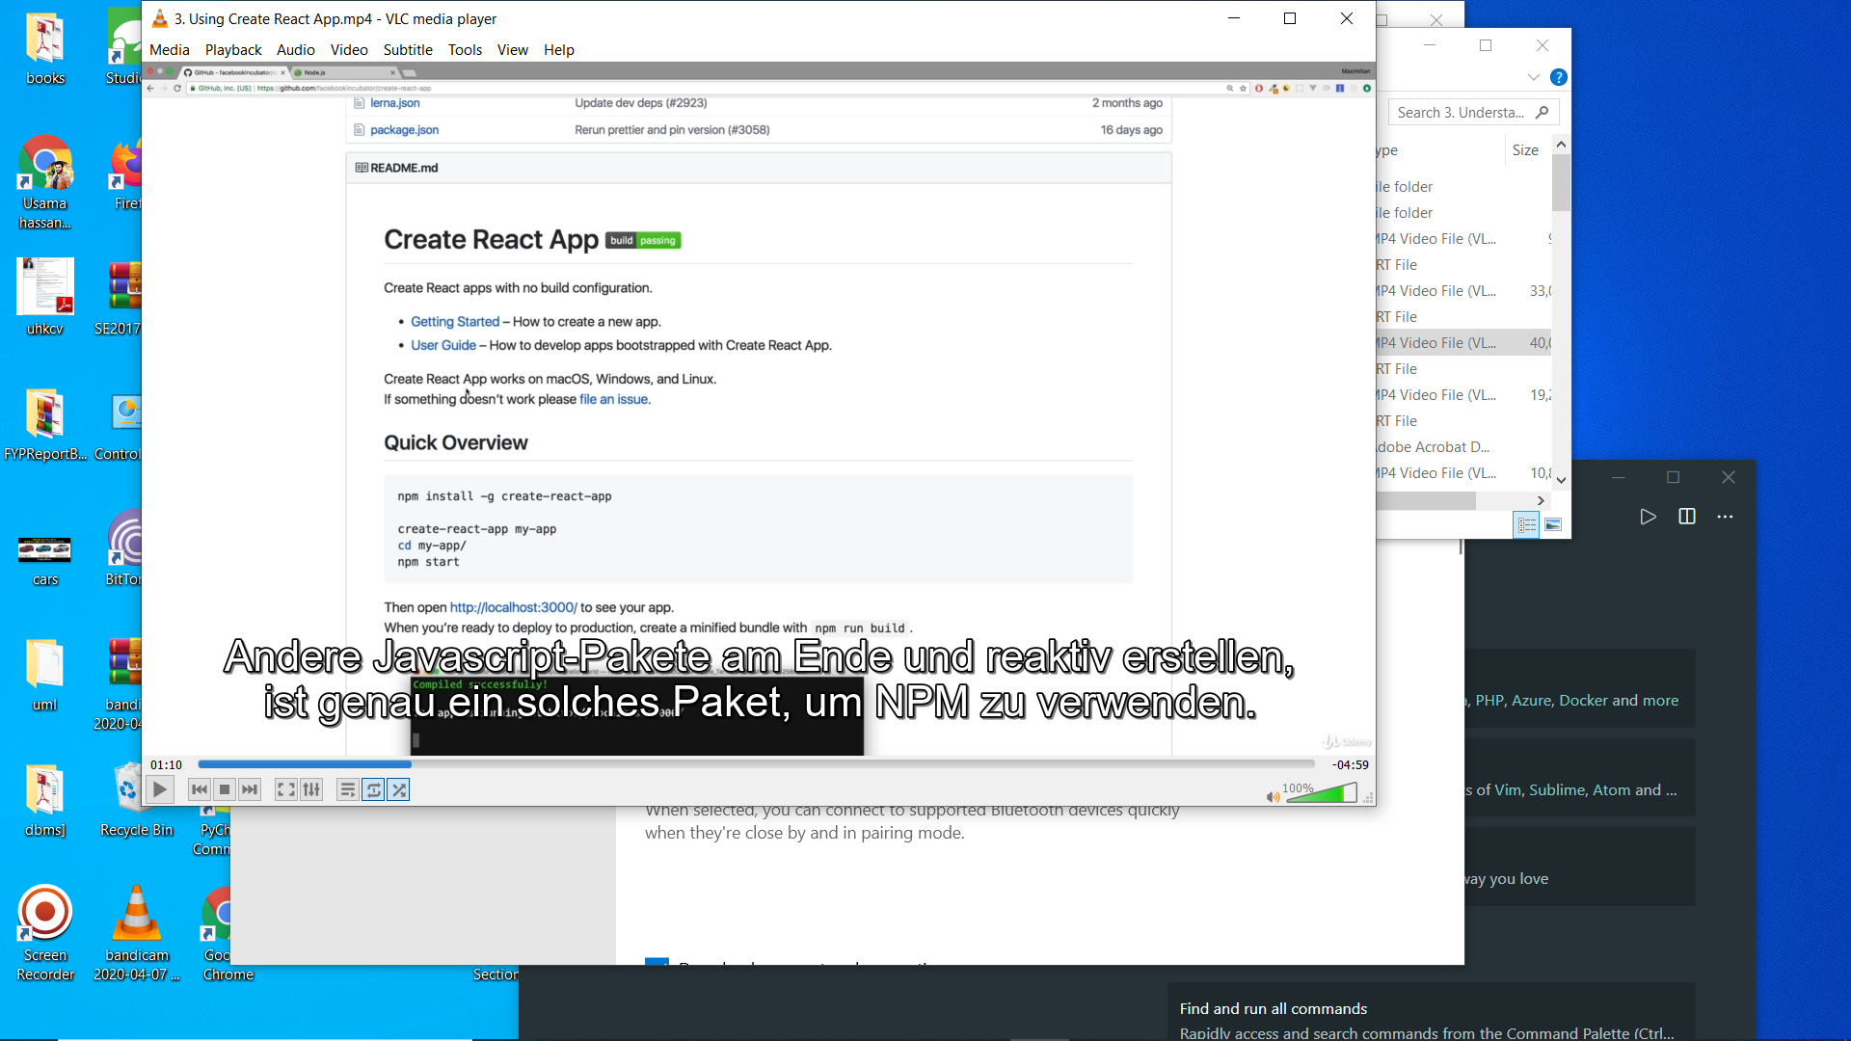

App.js

Import React form ‘react’;

class App extends React.Component{

  render(){

*return* (

      <h1>nice bro</h1>

    );

    }}

*export*  *default* App;

**index.js**

**ReactDOM.render(**

**<React.StrictMode>**

**<App />**

**</React.StrictMode>,**

**document.getElementById('root')**

**);**

**I reactdom take 2 param ist compntnt class 2nd div whiere it manioulae**

**Index.html where div ,changes will be reached there**

**U can return**

**React.createEleemnt(‘div’,null,”ni’) here u can pass csss property like {hear}**

**React.createEleemnt(‘div’,{className:’App’}, React.createElemnt(‘div’,null,”ni’))**

Create functional component *import* React *from* 'react';

var person=()=>{

*return*(

<h1>this is nice function</h1> );}

*export* *default* person;

and add in app.js

import Person from ‘.person/person’; person filder person file and then

</person>

Class component n

class Cmp extends Component { render () { return <div>some JSX</div> } }

props

ar person=(props)=>{

*return*(

<h1>this is nice function form {props.name}</h1>

    );

}

App..js

   <Person name="uhk"/>

Props.children pick in side tag value

State and setstate

class App extends React.Component{

  state={

    persons:[{

    name:"uhkstate",age:25

  }]}

  btnhandler=()=>{

    this.setState({

      persons:[{

      name:"uhkstatechange",age:27

    }]

  })}

  render(){

*return* (

    <div>

   <Person name={this.state.persons[0].name}/>

<button onClick={this.btnhandler}>wO</button>

</div>

   );

  }

}

*export*  *default* App;

react hook

use in function only

we can use state in class and hook in function and props in both

**cant use this keyword in hook**

**use function inside function here**

const App=props=>{

     const [state, setstates] = useState(

      {

        persons:[{

          name:"uhkstate",age:25

                 }]

      }

                                       )

const btnhandler=()=>{

  setstates({

    persons:[{

    name:"uhkstatechange",age:27

             }]

                 })

                    };

*return* (

    <div>

   <Person name={state.persons[0].name}/>

<button onClick={btnhandler}>wO</button>

</div>

          );

                    }

*export*  *default* App;

**use ref in component**

**ref is u not use{} in function call it run propmtly**

<Person click={this.btnhandler}/>

**In component**

**Props.click**

**This is used in class normal state**

**bind**

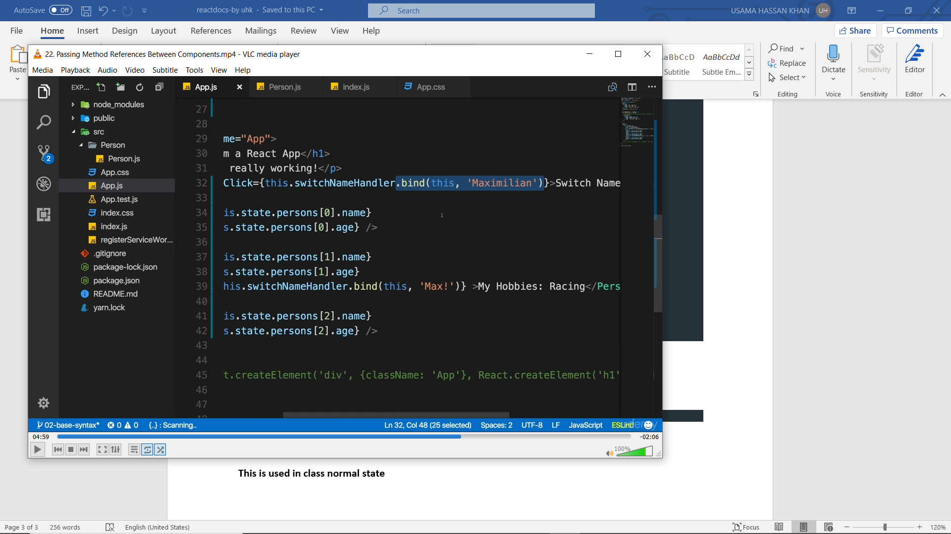

**Bind combine fnction on to other function if un use arrow function u don’t need to us ebind bcs arrow pick this to parent elemnt but if u are using nit mal function and use there thus keywrd so it will not pick parent funtio n so u have t o bind**

**Value cnhnage current**

 const namechangehandler=(event)=>{

        setstates({

        persons:[{

        name:event.target.value,age:27

                 }]

           })

         };

<Person namechng={namechangehandler} />

**In compnntn**

**{Props.namechng}**

Css u can make file in src where u made compont in folder in src and creae css and link in app,js

Like

Peron foldr

Person.js js component

Persom.css css

So import ‘./person.css’

Use it above render function

 const style={

    color:'red',

    fontsize:'200px'

  }

And call {style}where u wana gove this style

Works only in class

Condition

const App=(props)=>{

   const state={

    person:[{name:"uhkharry0",age:"23"},

    {name:"uhkharry1",age:"24"},

    {name:"uhkharry2",age:"25"}

           ],

    showpersons:false

  }

*return*(

<div>

  {

    state.showpersons ?

 <div>

    <h1>{state.person[0].name} and {state.person[0].age} </h1>

    <h1>{state.person[1].name}and {state.person[0].age}</h1>

    <h1>{state.person[2].name} and {state.person[0].age}</h1>

    <Person/>

    </div> :null

   }

   </div>);

  }

Or

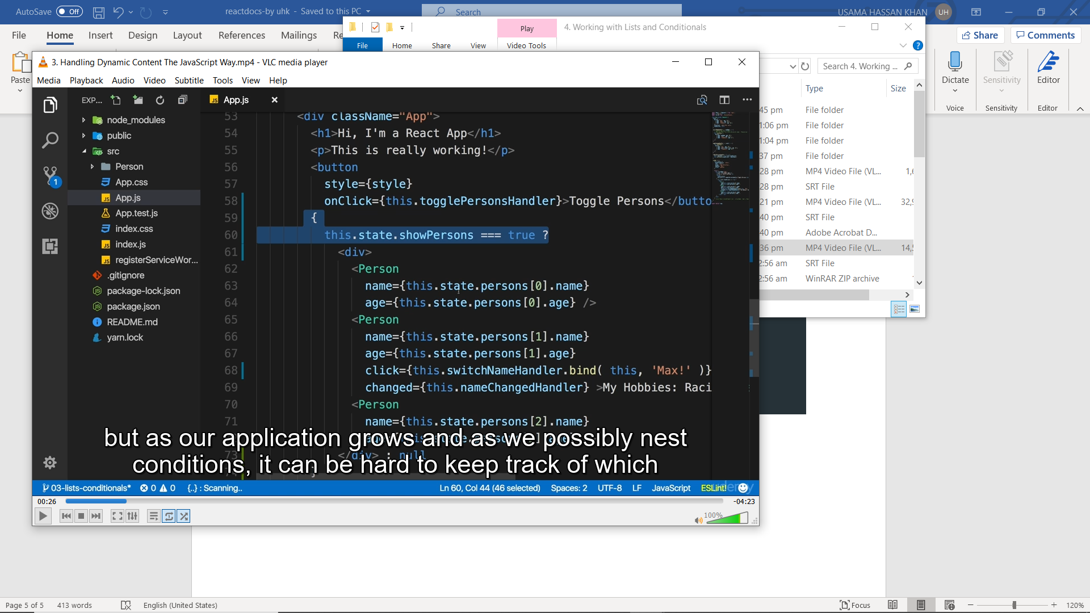

import React, { Component } from 'react';

import './App.css';

import Person from './Person/Person';

class App extends Component {

state = {

persons: [

{ name: 'Max', age: 28 },

{ name: 'Manu', age: 29 },

{ name: 'Stephanie', age: 26 }

],

otherState: 'some other value',

showPersons: false

}

render () {

const style = {

backgroundColor: 'white',

font: 'inherit',

border: '1px solid blue',

padding: '8px',

cursor: 'pointer'

};

let persons = null;

if ( this.state.showPersons ) {

persons = (

<div>

<Person

name={this.state.persons[0].name}

age={this.state.persons[0].age} />

<Person

name={this.state.persons[1].name}

age={this.state.persons[1].age}

<Person

name={this.state.persons[2].name}

age={this.state.persons[2].age} />

</div>

);

}

return (

{persons}

);

}

}

export default App;

render run whenere u rfresh

return only run one

so its better to put code on render and call {} in to return like above

replace above code in to map

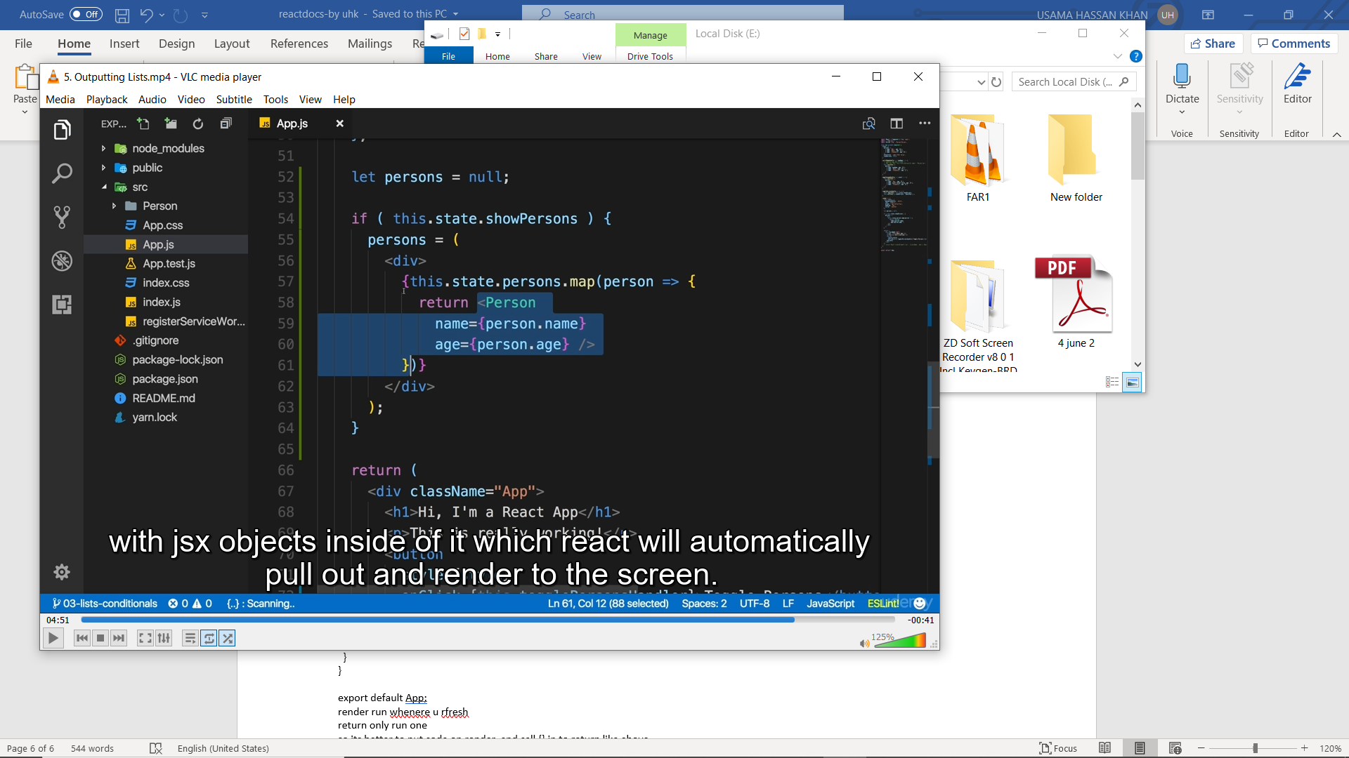

deletePersonHandler = (personIndex) => {

// const persons = this.state.persons.slice();

const persons = [...this.state.persons];

persons.splice(personIndex, 1);

this.setState({persons: persons});

}

if ( this.state.showPersons ) {

persons = (

<div>

{this.state.persons.map((person, index) => {

return <Person

click={() => this.deletePersonHandler(index)}

name={person.name}

})} </div> ); }

Put id

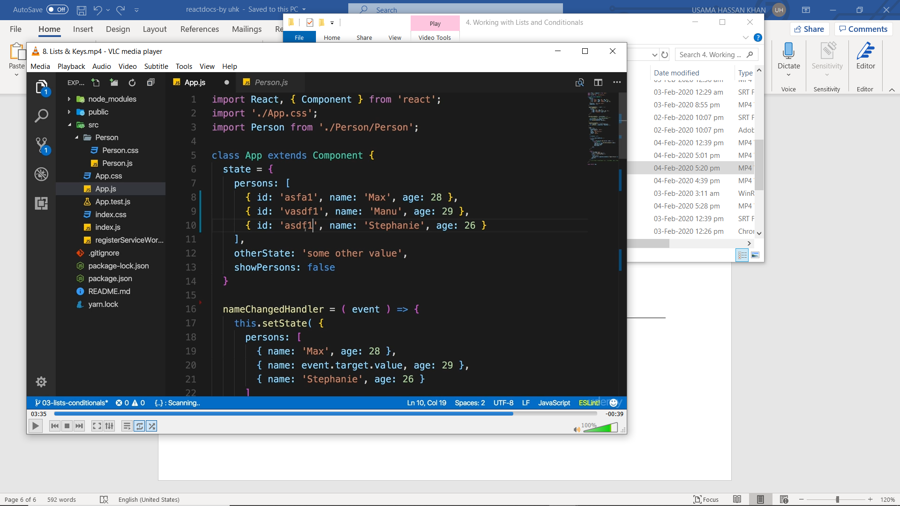

And then us to remove error u have t use id in map always

